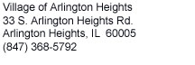
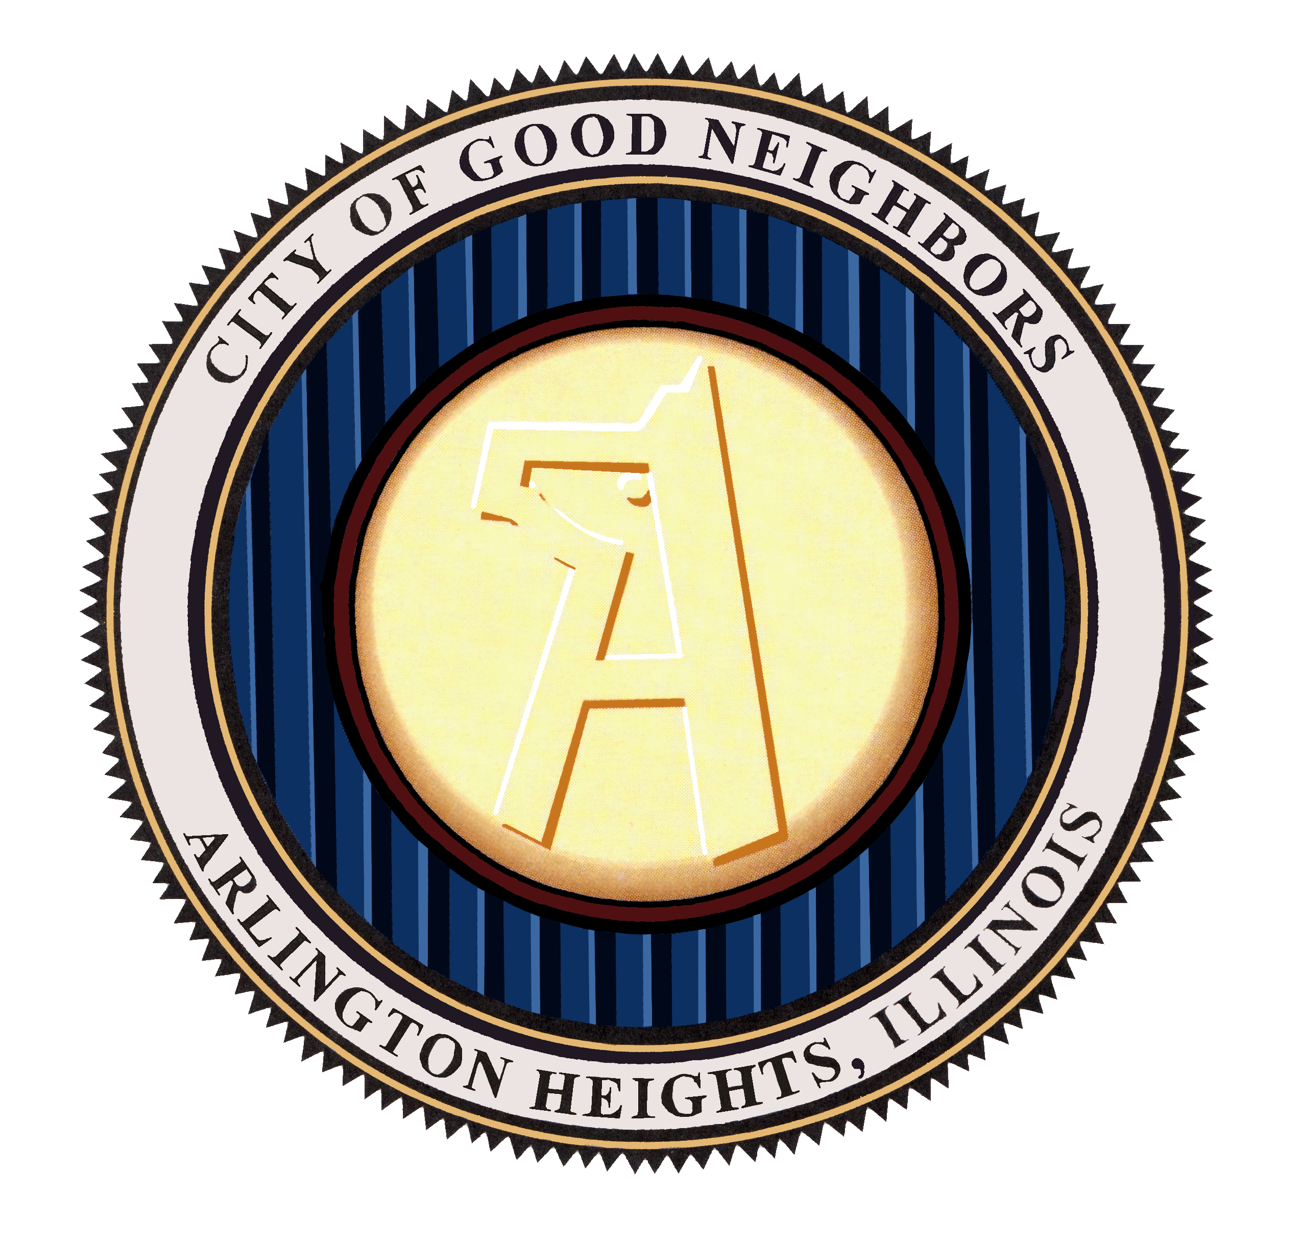

*Print name clearly *
IF YOU HAVE PARTICIPATED IN THE VILLAGE OF ARLINGTON HEIGHTS HOLIDAY PROGRAM THREE (3) YEARS IN A ROW
YOUR APPLICATION WILL NOT BE ACCEPTED. FIRST-TIME APPLICANTS WILL BE CHOSEN FIRST.
Village of Arlington Heights
HOLIDAY ASSISTANCE PROGRAM-2013

The purpose of this application is to determine whether the applicant is eligible for the Holiday Assistance Program 2013. All information contained herein shall be kept confidential.
Please return completed application no later than November 1 to:
Village of Arlington Heights
Holiday Assistance Program
33 S. Arlington Heights Rd.
Arlington Heights, IL 60005

I hereby apply for the Holiday Assistance Program 2013 through the Village of Arlington Heights. All information contained herein is accurate. I authorize the Village Human Services Coordinator/staff to verify any/all information given and for my name and address to be compared with the lists of other agencies. I may only receive gifts from one local agency program. I may be removed from the Village’s list if it is discovered that I am on multiple lists.
Any applications with missing information will not be processed. All required fields (indicated by an*) must be completed or applicant will not be eligible for the program
If you are on another local holiday gift program, you will be removed from the Village’s Holiday Program. If you do not qualify for this program, we will call you, otherwise you will be notified when you may pick up your gifts.

REQUIRED DOCUMENTS (necesario documentos)

- Lease and utility bill with your name and address clearly marked.

- ID: Drivers license, State ID, Medicaid card, or some official document with name and address for all members in the household including children.
Children may use medical card or something from their school showing proof of residency.
Birth certificates or Social Security Cards are no longer accepted.

- Proof of current total household income BEFORE TAXES for at least 30 days.
If you receive cash payments we will need a notarized letter from your employer.

Signature (firma) ______________________________________ Date (fecha)_________________

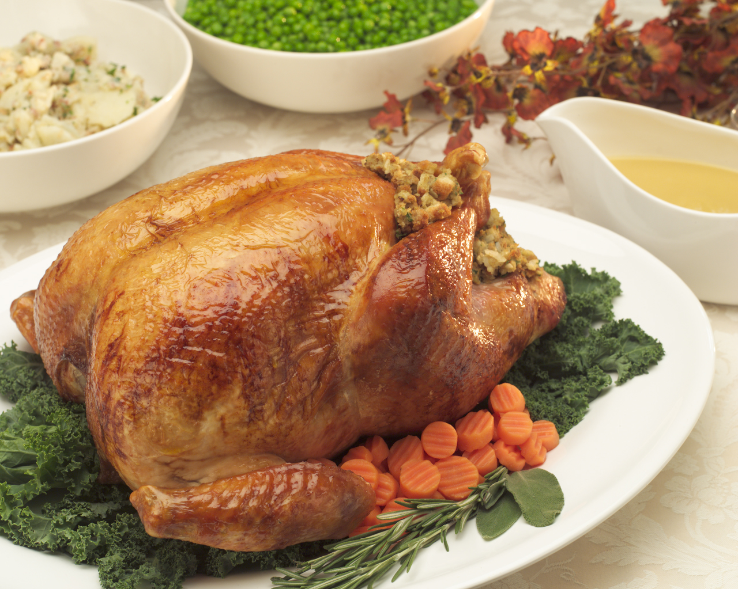If we receive donated turkey certificates would you be interested in receiving one?
(one per family)
(check only one) Thanksgiving Christmas

*Required (necesario)
APPLICANT (solicitante)

FULL NAME
LAST (apellido) FIRST (nombre)
ADDRESS (direccion)
number street city state zip
TELEPHONE (numero de telephono)
EMAIL: HOME
DATE OF BIRTH (fecha de nacimiento) MALE (hombre) ☐ FEMALE (mujer) ☐
*Required (necesario)

EMPLOYMENT (empleo)
EMPLOYERS NAME (nombre del patron)
ADDRESS

TELEPHONE HOW LONG EMPLOYED

*REQUIRED (necesario)
(This information must be included to be eligible for this program)
Please list all combined family income BEFORE TAXES, including wages, child support, public aid, food stamps etc., include any children working. If older children are not working, please explain why.
Any further comments or explanations can be included on the back of this page.

Source of income | Amount $ monthly
Wages | $
SSI, SSDI, Social Security | $
Child Support | $
Pension | $
Interest payments | $
Other | $
FILL IN THE AMOUNT($) FOR ALL THAT APPLY
HUSBAND/WIFE/PARTNER (ESPOSO)

FULL NAME
LAST FIRST MIDDLE

DATE OF BIRTH (Fecha de nacimiento) Age

MALE (hombre) FEMALE (mujer)

EMPLOYMENT OF SPOUSE (EMPLEO DEL ESPOSO)

EMPLOYER'S NAME (nombre del patron)

ADDRESS (direcciones de la empleo)
number street city state zip
TELEPHONE (telephono) HOW LONG EMPLOYED (¿cuánto tiempo empleado?)

*PLEASE COMPLETE THE FOLLOWING INFORMATION REGARDING YOUR FAMILY:
Please indicate, for each household member, 3 or 4 items that they need (coats, boots, clothing items, etc.) Then list 3 or 4 items they would desire (games, toys, etc.) These are only suggestions. Understand that you may not receive everything asked for.

- NAME (nombre) Male (hombre) Female (mujer)

Age (¿cuantos anos?)_______

CLOTHING SIZES (tamaño): PANTS (pantalones)______ SHOES(zapatos)________ SHIRT (camisas)________

- ________________________________ 1. ________________________________
- ________________________________ 2. ________________________________
- ________________________________ 3. ________________________________
- ________________________________ 4. ________________________________

- NAME (nombre) Male (hombre) Female (mujer)

Age (¿cuantos anos?)_______

CLOTHING SIZES (tamaño): PANTS (pantalones)______ SHOES(zapatos)________ SHIRT (camisas)________

- ________________________________ 1. ________________________________
- ________________________________ 2. ________________________________
- ________________________________ 3. ________________________________
- ________________________________ 4. ________________________________

- NAME (nombre) Male (hombre) Female (mujer)

Age (¿cuantos anos?)_______

CLOTHING SIZES (tamaño): PANTS (pantalones)______ SHOES(zapatos)________ SHIRT (camisas)________

- ________________________________ 1. ________________________________
- ________________________________ 2. ________________________________
- ________________________________ 3. ________________________________
4. ________________________________ 4._________________________________

- NAME (nombre) Male (hombre) Female (mujer)

Age (¿cuantos anos?)_______

CLOTHING SIZES (tamaño): PANTS (pantalones)______ SHOES(zapatos)________ SHIRT (camisas)________

- ________________________________ 1. ________________________________
- ________________________________ 2. ________________________________
- ________________________________ 3. ________________________________
- ________________________________ 4. ________________________________

- NAME (nombre) Male (hombre) Female (mujer)

Age (¿cuantos anos?)_______

CLOTHING SIZES (tamaño): PANTS (pantalones)______ SHOES(zapatos)________ SHIRT (camisas)________
- ________________________________ 1. ________________________________
- ________________________________ 2. ________________________________
- ________________________________ 3. ________________________________
- ________________________________ 4. ________________________________

- NAME (nombre) Male (hombre) Female (mujer)

Age (¿cuantos anos?)_______

CLOTHING SIZES (tamaño): PANTS (pantalones)______ SHOES(zapatos)________ SHIRT (camisas)________

- ________________________________ 1. ________________________________
- ________________________________ 2. ________________________________
- ________________________________ 3. ________________________________
- ________________________________ 4. ________________________________

- NAME (nombre) Male (hombre) Female (mujer)

Age (¿cuantos anos?)_______

CLOTHING SIZES (tamaño): PANTS (pantalones)______ SHOES(zapatos)________ SHIRT (camisas)________

- ________________________________ 1. ________________________________
- ________________________________ 2. ________________________________
- ________________________________ 3. ________________________________
- ________________________________ 4. ________________________________

- NAME (nombre) Male (hombre) Female (mujer)

Age (¿cuantos anos?)_______

CLOTHING SIZES (tamaño): PANTS (pantalones)______ SHOES(zapatos)________ SHIRT (camisas)________

- ________________________________ 1. ________________________________
- ________________________________ 2. ________________________________
- ________________________________ 3. ________________________________
- ________________________________ 4. ________________________________

